SQL NOTE
SQL (Structured Query Language) is a standardized programming language for managing and manipulating relational databases.
- SQL can execute queries against a database
- SQL can retrieve data from a database
- SQL can insert records in a database
- SQL can update records in a database
- SQL can delete records from a database
- SQL can create new databases
- SQL can create new tables in a database
- SQL can create stored procedures in a database
- SQL can create views in a database
- SQL can set permissions on tables, procedures, and views
SQL includes statements(queries), that statements consist of keywords that are easy to understand.
Some of The Most Important SQL Commands
SELECT – extracts(fetches) data from a database
UPDATE - updates data in a database
DELETE - deletes data from a database
INSERT INTO - inserts new data into a database
CREATE DATABASE - creates a new database
ALTER DATABASE - modifies a database
CREATE TABLE - creates a new table
ALTER TABLE - modifies a table
DROP TABLE - deletes a table
CREATE INDEX - creates an index (search key)
DROP INDEX - deletes an index
SQL Commands are like instructions to a table. It is used to interact with the database with some operations. It is also used to perform specific tasks, functions, and queries of data. SQL can perform various tasks like creating a table, adding data to tables, dropping the table, modifying the table, set permission for users.
- DDL – Data Definition Language
- DQL – Data Query Language
- DML – Data Manipulation Language
- DCL – Data Control Language
- TCL – Transaction Control Language
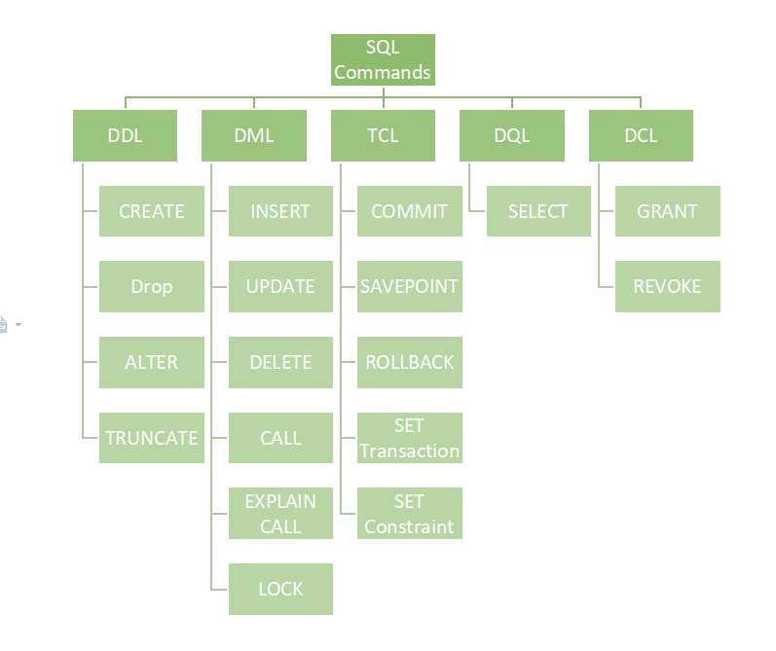
1. Data Definition Language (DDL) in SQL
DDL or Data Definition Language actually consists of the SQL commands that can be used to defining, altering, and deleting database structures such as tables, indexes, and schemas. It simply deals with descriptions of the database schema and is used to create and modify the structure of database objects in the database
CREATE - Create database or its objects (table, index, function, views, store procedure, and triggers)
SYNTAX:
CREATE TABLE table_name (column1 data_type, column2 data_type, ...);
DROP - Delete objects from the database
SYNTAX:
DROP TABLE table_name;
ALTER - Alter the structure of the database
SYNTAX:
ALTER TABLE table_name ADD COLUMN column_name data_type;
TRUNCATE Remove all records from a table, including all spaces allocated for the records are removed
SYNTAX:
TRUNCATE TABLE table_name;

